DRAFT MANUAL OF THE BUDGET AND FINANCIAL PROCEDURES FOR THE WCA REGION OF THE WORLD CUSTOMS ORGANIZATION

Version XXX du XX avril 2021
CONTENTS

- Presentation of the procedures manual
- Mapping of the budget and financial process in the WCA Region of WCO
- Budget and financial Procedure of the WCA Region of the WCO
  - Management Procedure of disbursements
  - Management Procedure for the expenditure engagement
  - Procedure of the follow up of cash-flow movement
  - Procedure of documents preservation

VERSION | DATE | MODIFIED PAGES | OBSERVATION | AUTHOR
V1 | 04/2021

The present manual of procedures is aimed at improving the budget and financial management, to ensure the reliability of the relevance of the system of information. This manual of procedures enables:
- To define the stages to follow in the performance of the duties;
- To track the circuit for the movement of documents;
- To define the roles extended to different actors at every stage of the execution of operations;
- To know the tools and documents of the actors in charge of carrying out the operations;
- To identify the main types of controls to comply with on a daily, weekly, monthly and annual basis;
- To indicate various levels of controls, self-control, top down control, internal audit etc
The word procedure means:
- The set of instructions to carry out duties;
- The necessary documents, their use, their issuing and their preservation;
- The mechanisms of control to put in place and their compliance.

- Presentation of the manual
  - Scope of application
This manual describes the management procedures for the inflows and disbursements of the WCO – WCA.
  - Objectives of the manual
This manual has as a general objective: the formalization of the management rules complying with the scope of application mentioned above. Its specific objectives are:
- The publication to all the actors of the inflows and outflows process of a manual of procedure complying with the missions of the regional structures and the missions of the WCO – WCA Vice Chair.;
- The creation of a formal framework for the management of inflows and outflows;
- The description of the conditions which enables an internal efficient control;
- The formalization of the controls to carry out as well as the identification the officers in charge.

  - Manual Updating
Any amendment to the procedure for its implementation or its adaptation gives obviously way to the updating of the present manual.
A manual of procedure is a scalable document. It can be amended, and regularly updated for the following reasons, among others:

- Amendment to the general and institutional organization of the situation;
- Necessity to improve the existing procedures to address two situations;
- Change imposed for the application of texts, decrees, ordinances and accounting rules;

The updating is done when decided by the Vice Chair of the WCO – WCA. following unexpected proposals from WCA Experts Committee or various services involved in the procedures, or recommendations from the financial or audit Committee.
The updating will consist in:

- Changing partly or totally the unsuitable former procedure;
- Changing the content of the concerned cycle procedure;
- Changing the number of pages of the concerned procedure;
- Updating all the files related to the changed part in the procedures;

The amended parts shall be copied or reproduced in many copies and shared to the structures or actors involved by the manual of procedure.

- MAPPING OF THE FINANCIAL BUDGET PROCEDURE FOR THE WCA REGION OF WCO
The Mapping of the financial budget procedure of the WCA Region is presented as follows:

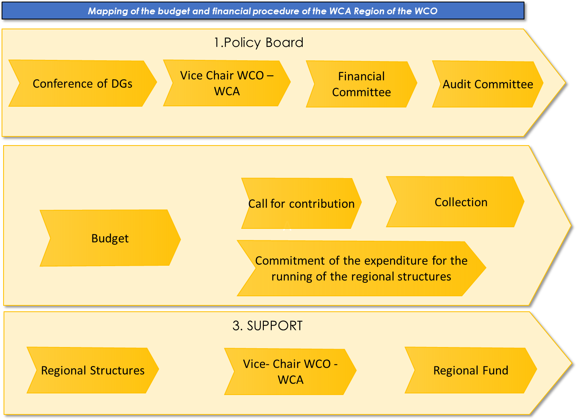

  - PROCEDURE OF INFLOWS MANAGEMENT

WCO - WCA | PROCEDURE OF INFLOWS MANAGEMENT |  | Reference :  Version :  Created on :
Manual of budget financial procedure

- Purpose of the procedure
The purpose of this procedure is to describe the modus operandi of the management of the inflows in the WCA Region of WCO.

- Office in charge of the process
The Officer in charge is The Vice Chair of the WCA Region of WCO.

- Rules of Management

- The sources of funding the WCA region off WCO are the contributions of the member countries (decided to the tune of 10,0000 Euros per year and by member country)
- The collection of the contributions is entitled to the Regional Fund.
- The management of the Budget is entitled to the competency of the Vice Chair of the WCA Region of WCO.

- Stages of the procedure

  - Call for contributions
  - Collection of the contributions

Stage | Acting | Roles description | Maximum Time of Processing | Documents or Interface
1 |  | Call for Contribution
 | Vice- Chair  Regional Fund | Issuing the call for contribution  - The amount for the annual contribution per member country is 10 000 euros.  - The Vice Chair for the WCA Region of WCO issues every year not later than 15 January, the call for contribution.  - The call for contribution includes the following information:  - Name of member country;  - The reference of the call for contribution;  - The period for the call for contribution;  - The particulars of the Regional Fund;  - The Bank references of the Regional Fund;  - The amount of the contribution.  - The calls for contribution are forwarded not later than 31 January, by mail to every representative of member countries with copy to the regional Fund Manager. | M | Call for contribution
2 |  | COLLECTION
 | The member countries  Regional Fund  Regional Fund  Vice-Chair WCO – WCA | - The contributions are required as from the month of February.  - The Settlement of the contributions are exclusively settled by bank transfer in the account of the regional fund.  - The particulars of the bank account of the regional fund are as follows:  - BANk : XXXXXXXX  - IBAN : XXXXXXXX  - SWIFT : XXXXXX  - RIB : XXXXXX  - The member countries send the payment by mentioning the description of the transfer as follows:  - Reference of the call for contribution/ The name of the country  - Settlements in cash are prohibited  - The regional fund manages holds a daily account book enabling to make the individual follow up of every member country’ s account.  Upturn  - The regional Fund issues every month the former balance presenting the dues of every member country.  - A recovery by mail is done every month to every member country after issuing the calls for contributions.  - Every quarter the balance is forwarded to the Vice chair for the WCA Region of WCO, for the recovery. |  | Former Balance

  - PROCEDURE OF THE EXPENDITURE ENGAGEMENT MANAGEMENT

WCO - WCA | PROCEDURE OF THE DISBURSEMENT MANAGEMENT | Reference :  Version :  Created on :
Manual of budget and financial procedures

- Purpose of the procedure
The purpose of the procedure is the modus operandi of the expenditure engagement within the Region WCO – WCA of the WCO.

- Officer in Charge of the Process
- The officer in charge of the procedure is the Vice Chair for the Region WCA of WCO.

- Rules of Management
- The budget of the WCA Region of WCO is adopted by the Conference of the Customs Directors General proposed by the financial Committee.
- THE budget of the Region WCA of the WCO is executed by stages: Commitment – Settlement - -Order for payment – Payment – Posting – A strict division is observed in the roles of accountability, at every stage, so that, there will be a lack of duplicate responsibility on incompatible budget functions.;
- The documents materialize the commitment of the WCA – WCO Region of WCO vis-à-vis the third, they can only be signed by the persons entitled with powers in one of the two following categories:
- They are directly accountable in the operation to carry out,
- They act under the order and the responsibility of the officer in charge, for example, in the case of purchasing or contract, operations related to the missions or travels etc.
- The budget is adopted for one year and is carried out during the year it is adopted;

- The budget period of the WCA Region of the WCO corresponds to the civil year: from January 1st to December 31st;
- An expenditure must be settled only if it is enshrined in the budget;
- A budget excess is authorized only in the limits provided by the procedure of the revision of the budget;
- The activities provided during a budget year and not achieved at the end of the budget can be brought forward to the next year.

- Stages of the procedure

  - Request for the Engagement
  - Authorization of the Engagement
  - Order for payment
  - Control and Follow up of the execution of the budget

Stage | Acting | Roles description | Maximum time of processing | Documents or Interfaces
1 |  | ENGAGEMENT REQUEST OR FUND REQUEST
 | Entitled Agent of the requesting regional structure | Issuing the EER  - All the needs in goods, works and services are expressed by an Expenditure Engagement request (EER).  - The EER is initiated by an entitled agent of the requesting regional structure  - The EER will mention compulsory the requesting regional structure, the budget references, the type of expenditure, the accurate reason of the envisaged expenditure.  - The amount envisaged (reason, budget line) shall be justified, mainly by a pro forma invoice when it comes to the first commitment about the concerned expenditure.  - In the framework of a contract signed, the requesting party shall mention the references of the contract, and attach a copy of that one.  - The EER higher than XXXX dollars USD will be subjected to the procedure for a call for tender.. | D | Authorization request for the expenditure commitment
 | Officer in charge of the requesting regional structure | Validation of the EER  - The validation is done by the Top manager (Officer in charge of the requesting structure) accountable for the budget of the operation or any other person holding internal power and duly authorized in that effect. | D+2
2 |  | ENGAGEMENT AUTHORIZATION
 | Vice-Chair of the WCA Region of the WCO  Vice-Chair of the WCA Region of the WCO. | Verification of the budget  - The EER is forwarded to the Office in charge of the regional structure for the control of costs and the consideration in the follow up of commitments then to the Vice Chair of the WCA of the WCO to check the legitimacy of the expenditure.  Authorized Expenditure  - Mention shall be done about the reference of the delegation of the budget granted by the Vice Chair of the WCA of the WCO on the grounds of the budget approved by the Customs DGs Conference.  - If the expenditure is not recorded or provided in the budget, the commitment cannot be authorized.  Validation  - The materialized authorization depends on the Vice Chair. However, in the framework of the discharge of His duties, for the Management of the WCA Region of the WCO, some officers holding internal power extended by the Vice Chair are entitled to validate the commitment authorization, in the limits of their area of respective competency and the amount authorized. | D+2  D+3
3 |  | ORDER FOR PAYMENT
 | Vice-Chair of the WCA of the WCO  Regional Fund | Order of payment or Good to pay  - The Vice Chair of the WCA Region of the WCO is the only one entitled to order to pay expenditure. In this respect, he signs all the files of Settlement as ‘’ Good to pay’’. Therefore, in the framework of the precedence of the power, the assignees appointed will be entitled to sign the files of Settlement in the limits within the limits set out by the texts in force.  - After the initials of the Vice Chair of the WCA Region of WCO, the files of settlement will be forwarded to the Manager of the Regional Fund for records and payment.  Settlement  - Deadline of the settlement  - The payments are settled within three days from the date of the reception of file of Settlement. The compliance of the deadline will enable the Regional Fund Manager to plan the payment in the framework of the availability of Cash.  - Means of Settlement: The settlements are done exclusively by bank transfer. The payments or withdrawals in Cash are prohibited.  - Records of the Settlements:  After payment, the bonds and means of payment are recorded in Accounting. The Manager informs the Vice Chair and the beneficiary structure by attaching with the copy of his mail, the written proof of the payment. | D+5  D+8
4 |  | FOLLOW UP AND CONTROL OF THE BUDGET EXECUTION
 | Regional structures  Financial and audit Committee  Regional Fund | - The regional structures realize every month a follow up of the budget execution and keep records of the written proof on the expenditure realized (EER – Authorization – invoices and bills – delivery form – order form - services etc).  - The financial Committee realizes every year a financial reporting on the budget execution.  - The control of the financial operations is ensured every year by the audit Committee. |  | Written proof documents of the expenditure  Financial Reporting

  - PROCEDURE OF THE CASH FLOW MANAGEMENT

WCO - WCA | PROCEDURE CASH FLOW MANAGEMEENT |  | Reference :  Version :  Creatod on :
Manual of Budget and financial Procedures

- Purpose of the procedure
The purpose of the procedures is to describe the modus operandi of the cash flow management of the WCA Region of WCO. This procedure includes the follow up of the previsions the control of the cash flow.
- Office accountable of the procedure
The accountable of the procedure is the Regional Fund.
Stage | Acting | Role Description | Documents or Interfaces
 | Regional Fund | Authorization on the Account  - The Authorization on the accounts of the regional Fund are the following : :  - XXXXXXXXX ;  - XXXXXXXXX ;  Follow up of the cash-flow  The regional fund realizes a cash-flow plan to follow up the evolution of the movement of the account.  - This plan will be updated every xxx and forwarded to the Vice Chair of the WCA Region of the WCO.  - The regional fund realizes the follow up of the bank reconciliation.  - He/she makes sure at least once a month about the compliance of the balance in realizing a reconciliation on the bank records;  - He/ she realizes the necessary verifications to identify the non-mentioned records;  Control of the cash-flow.  - The control organs of the WCA Region of the WCO periodically realize on the request of the Customs Directors General Conference the missions of controls of the cash-flow on the accounts of the WCA Region of the WCO. | Memo of the definition of the authorizations to communicate to the banks.  Cash-flow plan  Bank Reconciliation

  - PROCEDURE OF DOCUMENT PRESERVATION

WCO - WCA | PROCEDURE OF DOCUMENT PRESERVATION | Reference :  Version :  Created on :
Manual of Budget and financial procedure

- Nature of the Documents
The documents targeted include cashbooks, the purchase invoices, the bank statements, and all kind of written proof records, of the operations realized by the WCA Region of the WCO. These documents are very classified and preserved so as to authorize their user friendly access according to the need of usage.

- Timeframe of the Preservation
The legal duration of the preservation of the documents of the management is stated out for 10 years. However, according to the tradition and the importance of the operation, it is recommended to preserve the written proof documents corresponding to the goods and services for which they exist. As an example, for a real estate, the preservation duration recommended for the acquisition documents or the creation is 20 years at least.

Preserving the documents of the WCA Region of the WCO meets two obligations:
- Firstly, the preservation of the documents is a legal obligation set out by the internal Laws of every member country which states out the legal duration of the preservation of the management documents.
- Secondly, the preservation of the archives is needed for the reasons of justification as proof, for, these archives are essential during the claims, the controls of the administration, or in time of litigation, with a customer or a supplier. These documents are the evidence of the necessary rights and obligations to the discharge of its activity.

According to the nature of the documents, the durations varies: :

Nature of documents | Nature of the document | Legal duration (minimum)
Commercial | Commercial correspondence | 10 years
 | Accounts receivable | 10 years
 | Commercial or industrial correspondence | As long as the contract exists
 | Customers/ suppliers Order | 10 years
Documents & accounting books | Auxiliary cash books (Newspapers, Books,..) | 10 years
 | Description of accounting procedures | As long as the company exists
Documents & accounting books | Commercial invoices | 10 years
 | Contracts of acquisition of the transfer of real and personal estate, land etc | 10 years
 | Contracts of overdraft and loans | Duration of the contract
 | Insurance contracts | Duration of the contract
 | Deed of Lease | Duration of contract
 | Market contracts | Duration of the contract
 | Delivery forms and reception | 10 years
 | Order form | 10 years
 | Any document related to taxation , charges, and rights ( VAT declaration – IS declaration etc.) | 10 years

- Modalities of filing and archiving
The filing is a temporary operation for the written proof documents according to a method enabling to easily find them for their processing.
Archiving is an operation of definitive filing. It complies with the written proof documents on which all the controls have been done.

- The current archives preserved are at the reach of hands and always consulted;
Example: Invoices – delivery form – bank statement – oil contract etc.
- The intermediate archives: the use is less frequent and they are stored at places to be seen, for easy access, and physically secure;
Example: Financial statement of the ending year – Minutes of the general assembly - / Board of directors etc.
- The definitive archives (or historical) will never be consulted and can be destroyed at any time according to the duration of preservation.

The operation of classification or archiving may be physical, or electronic. The electronic management of documents consists in filing and archiving documents on magnetic supports like Cd – ROM per copy or stored in computer files and/or scanned documents to transfer.

This mode of classification and archives, is cheap and presents the advantage to save money, and in any case the CD – ROM you have documents which cannot be forged. However, the mode of physical classification and archive is the most used one.
The code of archive consists in mentioning on each type of documents or written proof:

- The type of diary,
- The month,
- The unique numbering for an expressed piece from 6 digital characters.
From the archive code which shows the number of the accounting documents, it is established a link between written proof and the reality of operations materialized by the written proof documents.
The diagram of the number pf pieces or code of archive indicated on the accounting document is presented as follows/:
Numbering of documents
Month
8 space bar
6 space bar

Type of diary

ACH1 _ 11 - 00914
So: ACH1_11-000914

- The tools of the classification and archive

The tools of physical classification and archive include mainly:
- Folders (simple, with cover, extensible, flexible, etc.);

- The lever arch file;

- The suspended files with vertical index (or horizontal) for being readable in the cupboard (or above in the drawers);

- The filing boxes;

- The boxes or the crates for archives.

